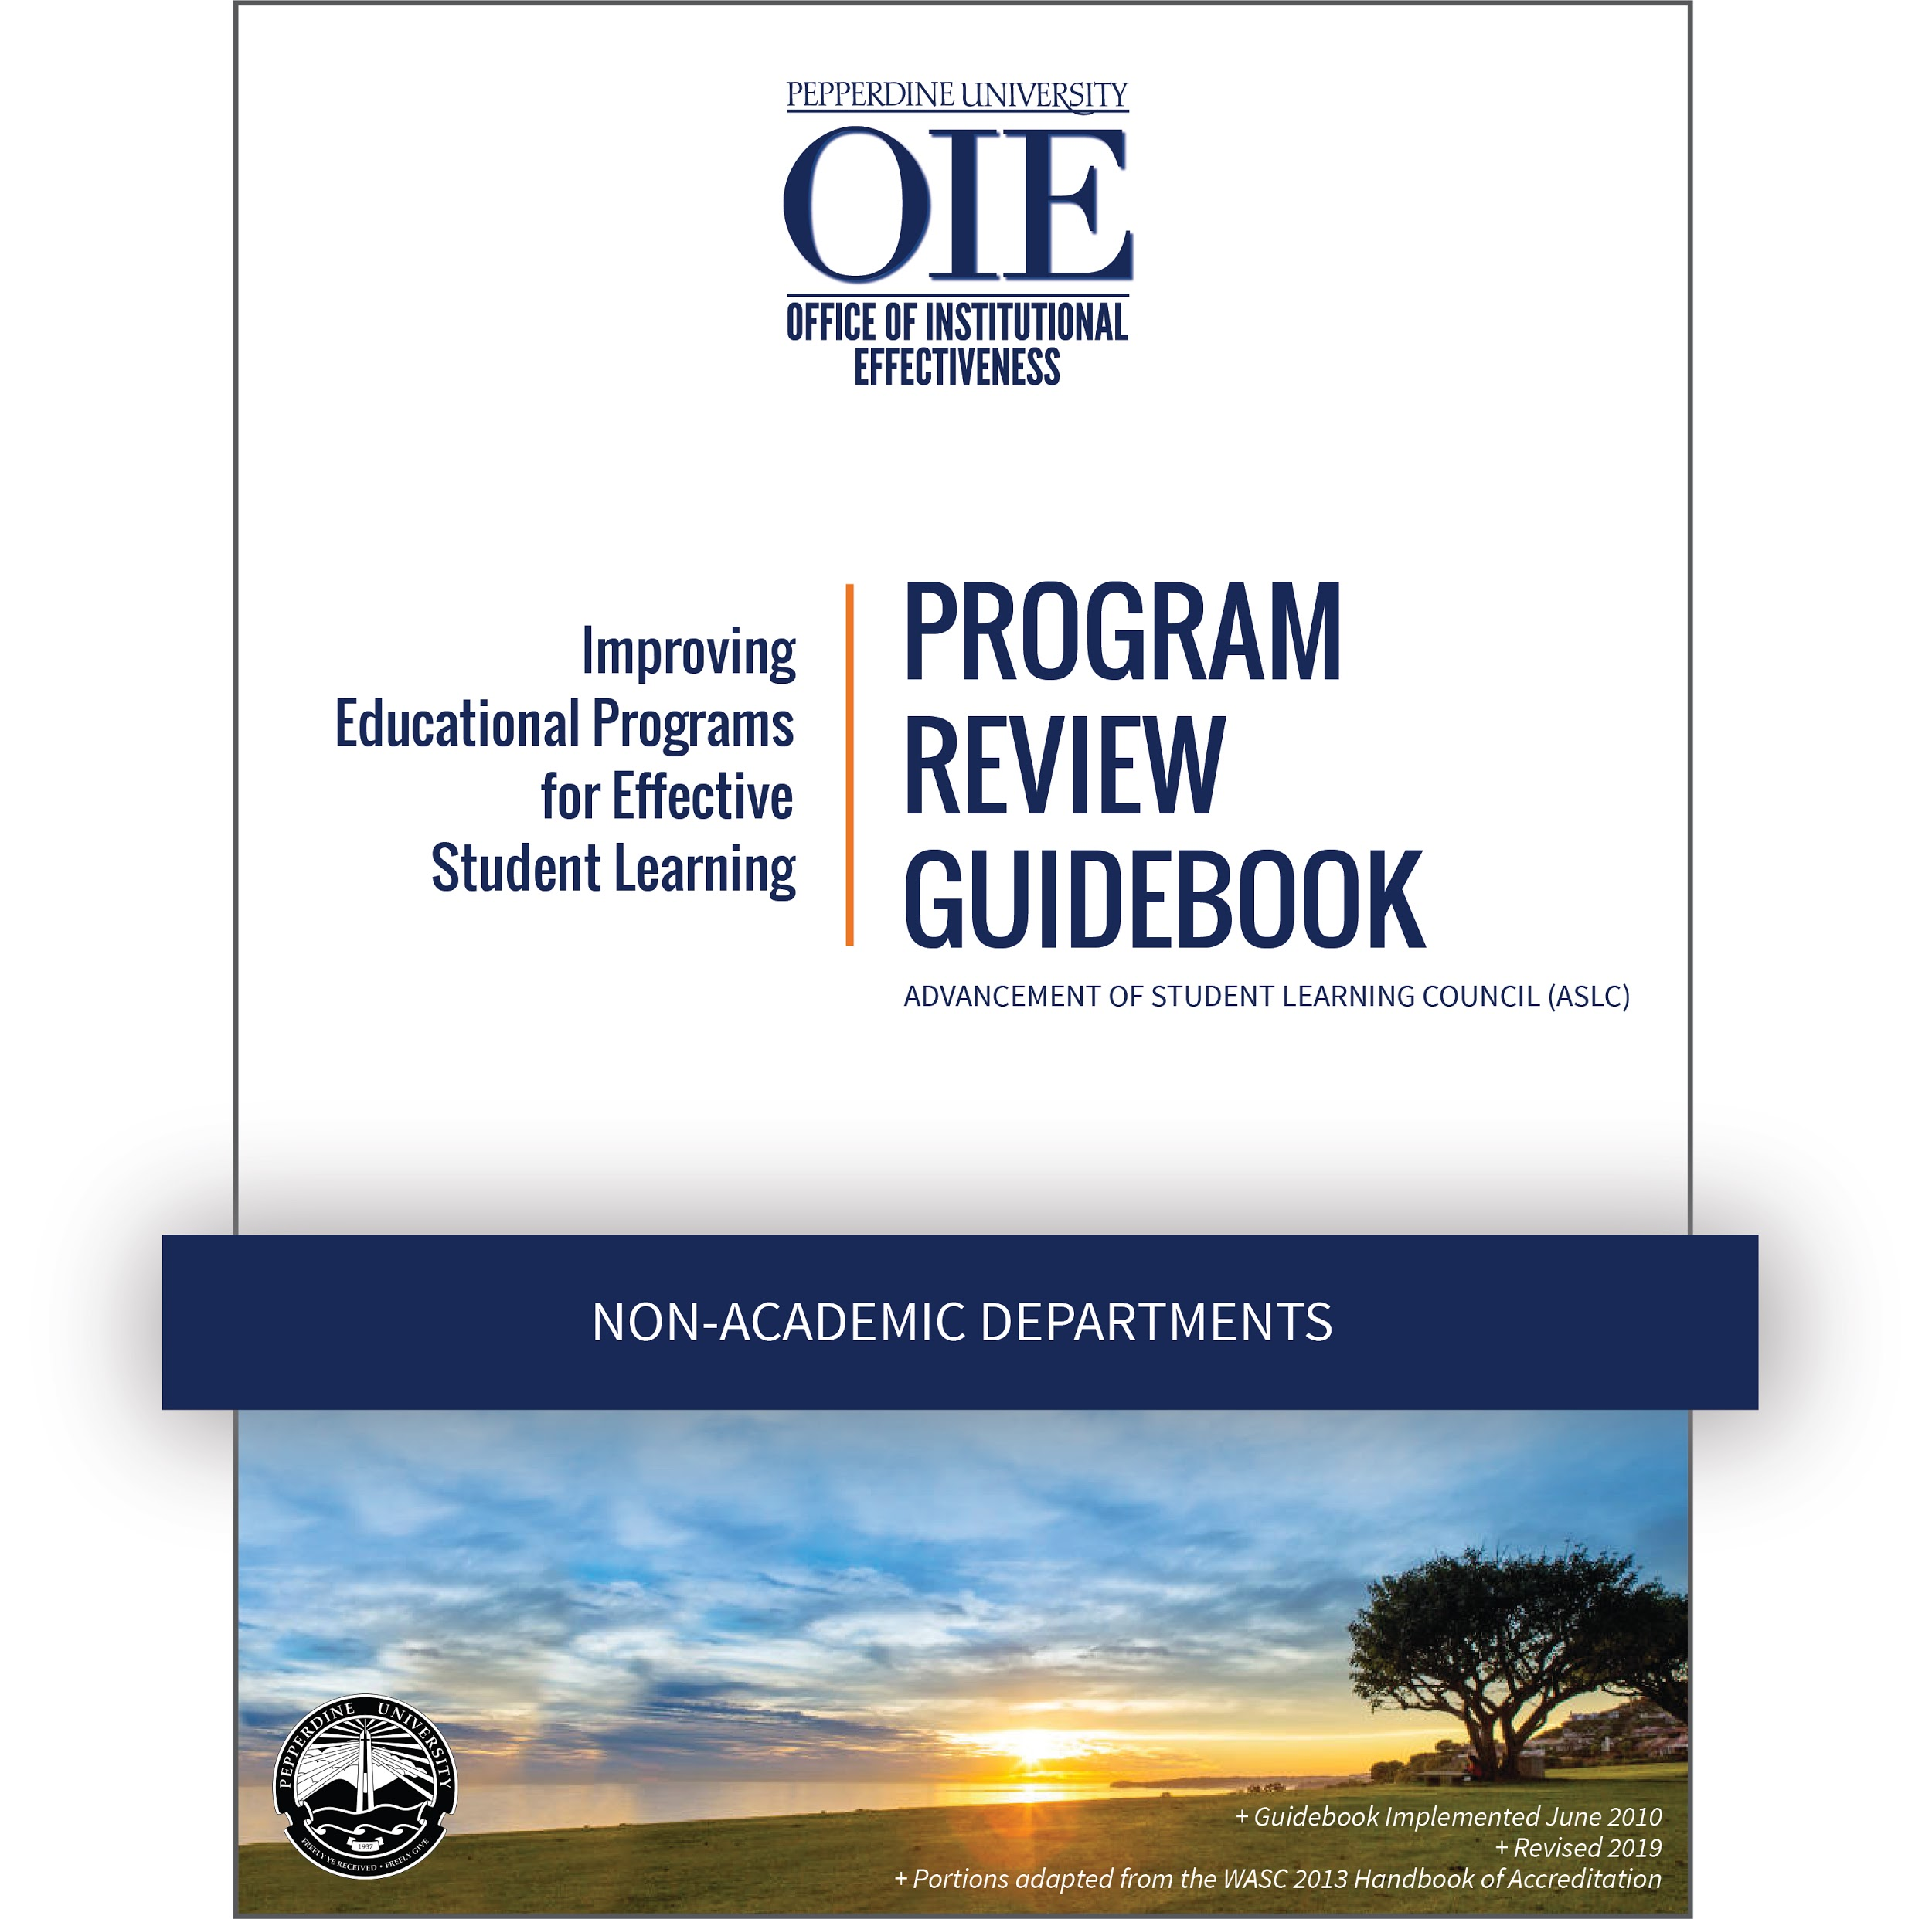

PROGRAM REVIEW SELF STUDY:

[PROGRAM NAME]

Date Prepared:

Principal Preparer:

Program Review Team Members:

Sections A and B provide context for the program. The information is largely descriptive and, in many cases, may be copied from other existing materials.

BACKGROUND
- Please provide a brief history of the program. (1 paragraph)

- Does the program engage the community outside of the University? YES □ NO □
If “yes,” please explain. (1 paragraph)

- What outside trends impact the work of the department? (1 paragraph)

B. MEANING OF THE PROGRAM: MISSION, GOALS, OUTCOMES

- Does the program have a mission statement? YES □ NO □
If “yes,” please paste it here.
If “no,” briefly explain why the program exists, its values, its work, and what it hopes to achieve in the future. You may wish to consider the creation of a mission statement in your QIP.

- Does the program have stated Program Goals? YES □ NO □
If “yes”, please paste them here.

- Does your program have Student Learning Outcomes? YES □ NO □
If “yes,” please paste them here.

- Discuss how the mission, goals, and outcomes support the University mission and add meaning to a student’s Pepperdine experience and degree. (1 paragraph)

Sections C, D, and E are a presentation and analysis of evidence about the program’s quality and viability. This section should use evidence to address the extent to which the program is meeting its objectives and adding value to a Pepperdine education.

C. QUALITY AND VIABILITY OF THE PROGRAM

- [Evidence 1] What services does the department provide and why are they needed?

(This section can be either a narrative or a table that lists services and the necessity for those services. Evidence of necessity may include established best practices, benchmarking, student feedback, published research, a direct link to the mission, etc. For example, evidence to support on-campus housing may include the goal of Seaver College to provide a residential education to 75% of students, while the evidence for having Greek organizations might be connected to best practices, student feedback, or research about finding community or evidence of student success.)

- [Evidence 2] What changes have been made and why since the last program review? Be sure to include items from your last QIP.

(Student Affairs departments should be able to copy and paste applicable information on their strategic initiatives from their SLO/SI report).

- [Evidence 3] Compare your department’s services to benchmarking data from peer and aspirational schools.

(This section can be either a narrative or a table)

- [Evidence 4] How many students use the services of the department? Show trends for each year of the evaluation period.
Provide data disaggregated by gender, ethnicity, age, school, and any other relevant variables. Compare your data to school or University data. Are there any group underutilizing the services?
(If you do not have demographic information in your department records, contact OIE. If you provide OIE with CWIDs, they can help you with demographics. If you do not have CWIDs, ask OIE if they have any sources of data that can help you. In the future you may want to consider more robust data collection as a QIP item.)
- [Evidence 5] Describe how the program obtains feedback from students and what that feedback indicates. Is there an interest in new or different programming?
- [Analysis] Reflecting on the above evidences, write an analysis of the services being offered. Are they the right services, do they meet student needs, are they well utilized, are they consistent with peer institutions and student expectations?
- [Analysis] Reflecting on the above evidences and trends in society or education, write an analysis of student usage and engagement. Is the program long-term sustainable, is there continued and consistent interest in the program or individual services, is there evidence supporting a need for programmatic change etc.?

D. INTEGRITY OF THE PROGRAM

- [Evidence] Please provide a link to each year’s evaluation of student learning outcomes.

(Student Affairs, this will be a link to your final SLO/SI report each year)

- [Evidence] Where possible, work with OIE to gather evidence of student success through graduation or retention rates.

- [Evidence] Where possible, report on alumni success. OIE can assist you in contacting and surveying identified alumni.

- [Evidence] Relevant National student surveys: OIE will provide a summary of this data.

- [Analysis] Reflecting on the evaluations of student learning and student success, take a holistic look at students in your department. Identify strength and growth areas in your own methodologies as well as student achievement.

E. ALLOCATION OF RESOURCES

PROFESSIONAL STAFF SUPPORT
 | YES | NO
Are there a sufficient number of program staff to maintain program quality?
Do program staff regularly engage in professional development?
Do program staff actively participate in regional or national organizations through membership, professional service, or presentations?

If you answered “no” to any of the questions above, please briefly explain and then offer suggestions as to how the situation could be improved.

INFORMATION AND TECHNOLOGY RESOURCES
 | YES | NO
Does the department have sufficient technology resources to support the program?
Does the department have sufficient information resources to support the program?

If you answered “no” to any of the questions above, please briefly explain and then offer suggestions as to how the situation could be improved.

FACILITIES
 | YES | NO
Are the facilities sufficient to support the program?
Office Space
Access to Conference Rooms
Other
Other

If you answered “no” to any of the questions above, please briefly explain and then offer suggestions as to how the situation could be improved.

Sections F is a plan for quality improvement based on your evidence and analysis in the previous sections.

F. SUMMARY, REFLECTIONS, AND PLANS FOR THE FUTURE
- Please write a short summary of your most significant findings.

- Based on your evidence and analysis, what changes need to be made to continue to advance the quality of the program over the next five to seven years? This section will serve as the beginning of your final Quality Improvement Plan (QIP) following the external review. Include the following information for each item. You may complete this section as a narrative or in a Table format. Depending on the scope of the change, this section may include anywhere from three to eight items.

  - What is the needed change?
  - What is the rationale for the change?
  - When would you make the change?
  - Who is responsible for making it happen?
  - Are there needed resources and if so what?

- Examples may include:
  - Revisioning department programming to improve student engagement.
  - Developing or refining program learning outcomes.
  - Identifying appropriate means for assessing student learning and success.
  - Better aligning departmental goals with institutional goals.
  - Designing programming to appeal to underserved populations.
  - Creating new partnership with related or complementary services.

APPENDIX

