Pepperdine Dialogue Dinners: Discernment through Discussion
Reading | Speaker | Event | Date and Time | Location
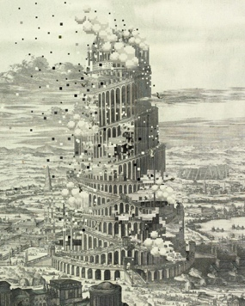 | Jonathan Haidt, NYU, Stern School of Business | President’s Speaker Series | Wed., Sep. 21, 2022  5:30 – 7:00 pm | Smothers Theatre
 |  | Dialogue Dinner  “Why The Past 10 Years Of American Life Have Been Uniquely Stupid” | Fri., Sep. 23, 2022  5:30 - 8:30 pm | Brock House
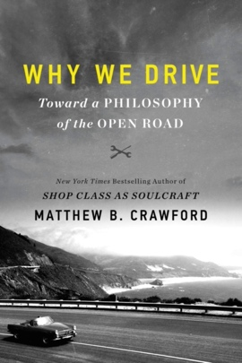 | Matthew B. Crawford,  University of Virginia, Institute for Advanced Studies in Culture | Office of the Provost  Faculty/Staff Leadership Conference | Fri., Oct. 7, 2022  9:00 -10:00am | Four Seasons, Westlake
 |  | Dialogue Dinner  Why We Drive: Toward a Philosophy of the Open Road | Fri., Oct. 28, 2022  5:30 - 8:30pm | Brock House
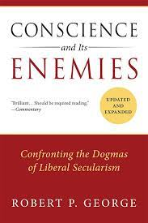 | Robert P. George,  Pepperdine University and James Madison Program in American Ideals and Institutions at Princeton University | School of Public Policy  The Reagan Lecture | Thu., Nov. 17, 2022  11:00 am - 1:00 pm | Ronald Reagan Presidential Library
 |  | Dialogue Dinner  Conscience and its Enemies: Confronting the Dogmas of Liberal Secularism | Fri., Jan. 13, 2023  5:30 - 8:30 pm | Brock House
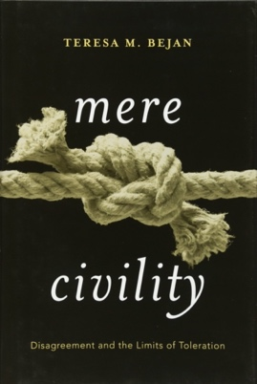 | Teresa Bejan,  Oriel College, Oxford | Seaver College  W. David Baird Lecture Series | Tue., Feb. 7, 2023  5:00 – 6:30 pm | Elkins Auditorium
 |  | Dialogue Dinner  Mere Civility: Disagreements and the Limits of Toleration | Fri., Feb. 24, 2023  5:30 - 8:30 pm | Brock House

